--------------------------------------------------------------------------------------------------------

4. Assuring the Cost Structure and selling prices remain same in period I and II Find out:

1 |  | P/V Ratio
2 |  | Break Even Point
3 |  | Contribution –for two periods
4 |  | Margin of Safety – for two periods
5 |  | Calculate the volume of sales to earns profit
 |  | of Rs.20,000
6 |  | Profit When Sales are Rs.1,00,000
period |  |  | Sales | Profit (Rs)
 |  |  | (RS)
I |  |  | 1,20,000 | 9,000
II |  |  | 1,40,000 | 13,000

Solution:

Comparative Statement showing profitability of two periods

Period |  |  | Sales | Profit
II |  |  | 1,40,000 | 13,000
I |  |  | 1,20,000 | 9,000
Increase |  |  | 20,000 | 4,000
1 |  | P/V Ratio : increase in profit / increase in sales * 100 (4,000/20,000*100)=20%
2 |  | BEP:F/PV ratio (15,000/20%)=75,000
3 |  | Contribution –for two periods |  |  |  | I |  | C = 1,20,000*20% = 24,000
 |  | C=S* PV Ratio then C-p = F
 |  |  |  |  |  | II |  | C = 1,40,000 * 20% =28,000
4 |  | Margin of safety – for two |  |  |  |  | I |  | 9,000*20%=45,000
 |  | periods
 |  |  | M/S= P/PV Ratio |  |  |  | II |  | 13,000*20%=65,000
 |  |  |  |  |  |  |  | 8

- Sales Required to earn a Desired Profit of Rs.6,000 = F+ D /P/v Ratio 15,000+20,000/20% = Rs.1,75,000
6 | P= C-F 20,000-15,000= Rs.5,000
Profit When Sales are Rs.1,00,000
C=S*PVR 1,00,000*20% = Rs.20,000

5.What do you understand by contribution ? How does it help the management to solving various problem?

Marginal costing technique makes use of marginal contribution for marking various decisions. Marginal contribution is the difference between sales and marginal cost. It forms the basis for judging the profitability of different products or departments Advantages
The technique is less complicated and free from confusion.

Under this technique net profit is not affected by the changes in production level or changes in stock volume; in fact profit is directly related to sales.

Reports based on this technique provide information based on sales rather than production conveying real estate of efficiency.

It helps in profit planning, particularly of short term nature. Disadvantages

It lays too much emphasis on selling function and as such production function has been considered to be less significant.

Valuation of stock only at Marginal cost may amount to under-valuation from the financial manager’s view point and this may have working capital problem.

Not suitable for external reporting, viz., for tax authorities where marginal income is not considered to be taxable profit.

This technique does not attach due importance to time factor.

6.From the following data you are required to calculate the break even point and net sale value at this point

Selling price per unit RS.24

Direct material cost per unit Rs. 8

Direct labour cost per unit Rs.5

Fixed overhead | Rs 24,000

Variable overheads @ 60% on direct labour

Trade discount 4%

If sales arre 15% and 20% above the break even volume determine the net profits.

9

ANSWER BEP= 72000, if sales 20% above the break even determine profit (4800),if sales above the BEP find out profit( 3600)

7. Explain the marginal costing is a valuable aid for managerial decision.

Principles for marginal costing

- For any given period of time, fixed costs will be the same, for any volume of sales and production (provided that the level of activity is within the ‘relevant range’). Therefore, selling an extra item of product or service:

  - Revenue will increase by the sales value of the item sold

  - Costs will increase by the variable cost per unit

  - Profit will increase by the amount of contribution earned from the extra item

- The volume of sales falls by one item ➔ the profit will fall by the amount of contribution earned from the item.

- Profit measurement should be based on an analysis of total contribution. Since fixed costs relate to a period of time, and do not change with increases or decreases in sales volume, it is misleading to charge units of sale with a share of fixed costs

- When a unit of product is made, the extra costs incurred in its manufacture are the variable production costs. Fixed costs are unaffected, and no extra fixed costs are incurred when output is increased

- Features- 1.Cost Classification

- The marginal costing technique makes a sharp distinction between

- variable costs and fixed costs. It is the variable cost on the basis of

- which production and sales policies are designed by a firm following the

- marginal costing technique

- Stock/Inventory Valuation

- Under marginal costing, inventory/stock for profit measurement is valued at marginal cost. It is in sharp contrast to the total unit cost under absorption costing method

- Marginal Contribution

- Marginal costing technique makes use of marginal contribution for marking various decisions. Marginal contribution is the difference between sales and marginal cost. It forms the basis for judging the profitability of different products or departments.

5.Fixation of selling price

10

Fixation of selling price is one of the significant tasks of management. Prices are usually ascertained by market conditions and other economic aspects. Cost volume profit analysis supports the management in fixing the selling prices under diverse conditions. 6.Accepting bulk order or foreign market order

Some – bulk orders may be received from local dealer or foreign dealers asking for a price which is below the market price this calls for a decision to accept or reject the order the order from a local dealer should not be accepted at a price below the market price because it will affect the normal market and good will of the company on the order hand the order from the foreign dealer should be accepted because it will give additional contribution as the fixed costs gave already been met

7.Make or buy decision

In a make or buy decision the price quote by the outside suppliers should be compared with the margin cost of producing the component parts if the outside price of the component is lower than the marginal cost producing it it is worth buying on the other hand if the outside price is higher than the marginal cost making the component in the factory may be preferred

8.Selection of suitable product mix

When a factory manufactures more than one product a problem is faced by the management as to which product will give maximum profit the solution is the products which give the maximum contribution are to be retained and their production should be increased

9.Key Factor

It is also known as limiting factor or government factor or scarce a key factor is one which restricts productions and profit of a business it may arise due to the shortage of material Labour, captital , plant capacity or sale Normally when there is no limiting factor the selection of the product will be on the basis of the highest contribution per unit of the key factor

- Maintaining a desired level of profit

Management may be interested in maintaining a desired level of profit the sales required to earn a desired level of profit can be ascertained by the marginal costing techniques

- Alternative methods of production

Marginal costing is helpful in comparing the alternative methods of production machine work or hard work the method which gives maximum contribution is to be adopted keeping in mind the limiting factor

- Determination of optimum level of activity

The technique of marginal costing help the management in determining the optimum level of activity to make such a decision contribution at different level of activity can be found the level of activity which gives the highest contribution will be the optimum level the level production can be rises till the marginal cost does not exceed the selling price

13. Evaluation of performance

Evolution of performance efficiency of various department or product lines can be made with the help of marginal costing the management has to discontinue the production of non-profitable products or department so as to maximize the profits in such cases decision to discontinue will be on the basis of the lowest contribution or P.V.Ratio

- Decision making

Decision making is a process of selecting the best course of action from number of available alternatives. Problems like selection of method of manufacture using the production capacity for different products continuing or dropping of a product showing a loss expansion or change in market etc., call for a decision in such cases the decision should be made on the basis of contribution.

11

--------------------------------------------------------------------------------------------------

8.Explain the supply determinants in detail or supply shifters.

    - Input prices- producer are willing to produce less at each given price

  - Technological change-leads to produce more at a lesser cost, more efficient use of resources

  - Government regulation-support the industry like small scale industries and village industries then regardless of the price the output increases.

  - Number firms or competition-As additional firms enter an industry, more and more products become available in the market at a given price.

- taxes- a tax on each units of output sole, where the tax revenue is collected from the supplier

- Substitute in production- to increase the quantity supplied

- Producer expectation-producers can hold back outputs today and sell it later at a higher price.

---------------------------------------------------------------------------------------------------------------------------

----

9.Explain Demand determinants in detail or Demand shifters

  - General factors-price of the product (when the price of the product is increased, the purchasing power of the consumer is decreased and thereby reducing the demand for the product.
Income of the customer- the income increase the demand also increase in case of some commodities like fruits, vegetables petrol, diesel etc.

The demand a tastes and preferences of the consumers in favor of a commodity will result in a greater demand for the commodity. The opposite also holds good.
Price of related goods- (substitutes and complements)

  - Factor related to luxuries and durables- consumer’s expectation future prices(when a consumer expects a higher income in future, he spends more at present and demand for goods increases.
Consumer’s expectation of future income-the demands of the goods depend on the customer’s ability and the desire to buy that product.

  - Factors related to market demand- population, social economic geographic and demographic distribution of consumers.

- Explain Break Even Point With Diagram

Introduction

Break-even analysis is a technique widely used by production management and management accountants. It is based on categorizing production costs between those which are "variable" (costs that change when the production output changes) and those that are "fixed" (costs not directly related to the volume of production).

Total variable and fixed costs are compared with sales revenue in order to determine the level of sales volume, sales value or production at which the business makes neither a profit nor a loss (the "break-even point").

12

The Break-Even Chart
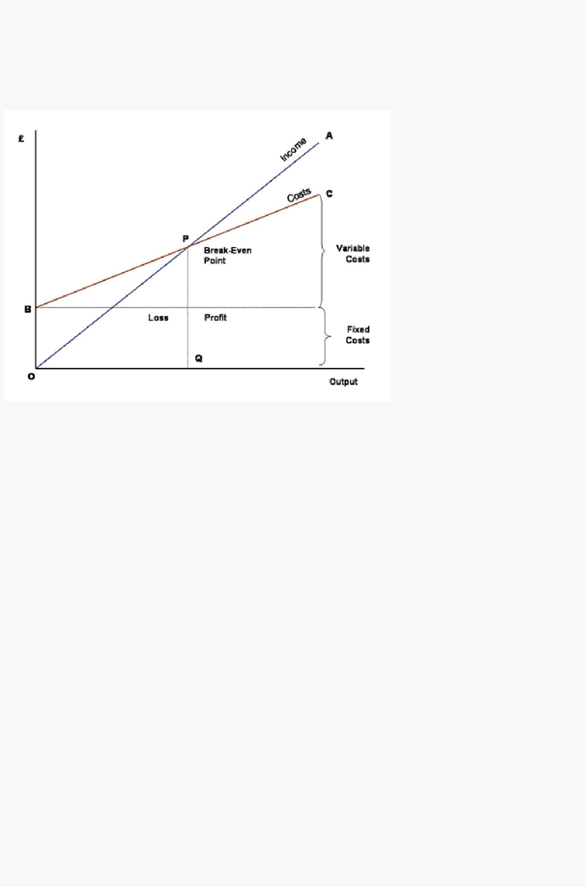
In its simplest form, the break-even chart is a graphical representation of costs at various levels of activity shown on the same chart as the variation of income (or sales, revenue) with the same variation in activity. The point at which neither profit nor loss is made is known as the "break-even point" and is represented on the chart below by the intersection of the two lines:

In the diagram above, the line OA represents the variation of income at varying levels of production activity ("output"). OB represents the total fixed costs in the business. As output increases, variable costs are incurred, meaning that total costs (fixed + variable) also increase. At low levels of output, Costs are greater than Income. At the point of intersection, P, costs are exactly equal to income, and hence neither profit nor loss is made.

Fixed Costs

Fixed costs are those business costs that are not directly related to the level of production or output. In other words, even if the business has a zero output or high output, the level of fixed costs will remain broadly the same. In the long term fixed costs can alter - perhaps as a result of investment in production capacity (e.g. adding a new factory unit) or through the growth in overheads required to support a larger, more complex business.

Examples of fixed costs:

- Rent and rates
- Depreciation
- Research and development
- Marketing costs (non- revenue related)
- Administration costs

Variable Costs

Variable costs are those costs which vary directly with the level of output. They represent payment output-related inputs such as raw materials, direct labour, fuel and revenue-related costs such as commission.

A distinction is often made between "Direct" variable costs and "Indirect" variable costs.

Direct variable costs are those which can be directly attributable to the production of a particular product or service and allocated to a particular cost centre. Raw materials and the wages those working on the production line are good examples.

13

Indirect variable costs cannot be directly attributable to production but they do vary with output. These include depreciation (where it is calculated related to output - e.g. machine hours), maintenance and certain labour costs.

Semi-Variable Costs

Whilst the distinction between fixed and variable costs is a convenient way of categorising business costs, in reality there are some costs which are fixed in nature but which increase when output reaches certain levels. These are largely related to the overall "scale" and/or complexity of the business. For example, when a business has relatively low levels of output or sales, it may not require costs associated with functions such as human resource management or a fully-resourced finance department. However, as the scale of the business grows (e.g. output, number people employed, number and complexity of transactions) then more resources are required. If production rises suddenly then some short-term increase in warehousing and/or transport may be required. In these circumstances, we say that part of the cost is variable and part fixed.

----------------------------------------------------------------------------------------------------------------

-----

14

