PART-B

. 1 Write the Short Notes on : Fixed Cost

Fixed costs (FC) are incurred independent of the quality of goods or services produced. They include inputs (capital) that cannot be adjusted in the short term, such as buildings and machinery. Fixed costs (also referred to as overhead costs) tend to be time related costs, including salaries or monthly rental fees. An example of a fixed cost would be the cost of renting a warehouse for a specific lease period. However, fixed costs are not permanent. They are only fixed in relation to the quantity of production for a certain time period. In the long run, the cost of all inputs is variable

Variable Cost

Variable cost (VC) changes according to the quantity of a good or service being produced. It includes inputs like labor and raw materials. Variable costs are also the sum of marginal costs over all of the units produced (referred to as normal costs). For example, in the case of a clothing manufacturer, the variable costs would be the cost of the direct material (cloth) and the direct labor. The amount of materials and labor that is needed for each shirt increases in direct proportion to the number of shirts produced. The cost "varies" according to production.

Contribution:

Contribution is the difference between sales and the variable cost and referred to as “ Gross Margin” It is Visualized as some sort of fund or pool out of which all fixed cost are to be met and to which each product has to contribute its share

The difference between contrition and fixed cost is either profit or loss as the case may be

4

Margin Of Safety

Marginal Costing necessitates analysis of cost in to fixed variable. It has been designed to help the management to have a clear perspective on the effect of these two type of cost on the profitability

margin and sales volume.
Present sales – Break even sales or | Profit
 | P/V Ratio
Margin Of safety can be improved by taking the following step.

- Increasing production

- Increasing selling price

- Reducing the fixed or the variable cost of both

- Substitution unprofitable product with profitable one

Angle of Incidence

This is the angle between sales line and total cost line at the BEP. It indicates the profit earning capacity of the concern. Large angle of incidence indicates a high rate of profit: a small angle indicate a low rate of earning to improve this angle contribution should be increased either by raising the selling price and /or by reducing variables cost It also indicates as to what extent the output and sales price can be changed to attain a desired amount of profit
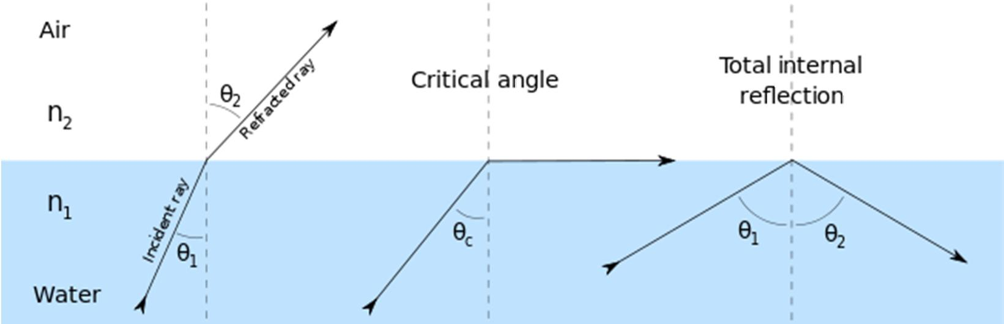

Profit Volume Ratio

CVP analysis expands the use of information provided by breakeven analysis. A critical part of CVP analysis is the point where total revenues equal total costs (both fixed and variable costs). At this break-even point, a company will experience no income or loss. This break-even point can be an initial examination that precedes more detailed CVP analysis.

CVP analysis employs the same basic assumptions as in breakeven analysis. The assumptions underlying CVP analysis are:

The behavior of both costs and revenues is linear throughout the relevant range of activity. (This assumption precludes the concept of volume discounts on either purchased materials or sales.)
Costs can be classified accurately as either fixed or variable. Changes in activity are the only factors that affect costs.

All units produced are sold (there is no ending finished goods inventory).

When a company sells more than one type of product, the sales mix (the ratio of each product to total sales) will remain constant.

5

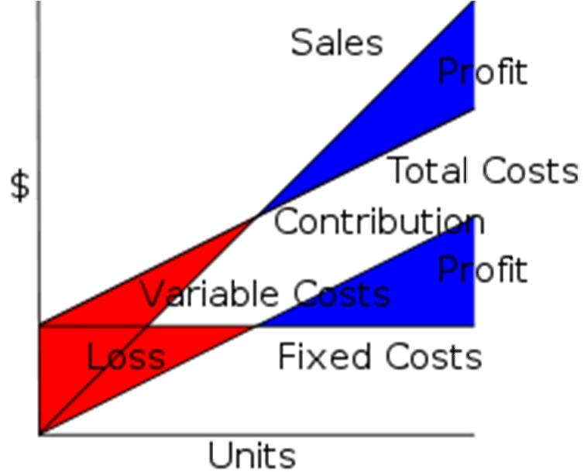

Break Even Point

y inserting different prices into the formula, you will obtain a number of break-even points, one for each possible price charged. If the firm changes the selling price for its product, from $2 to $2.30, in the example above, then it would have to sell only 1000/(2.3 - 0.6)= 589 units to break even, rather than 715.
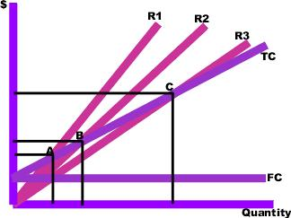

To make the results clearer, they can be graphed. To do this, you draw the total cost curve (TC in the diagram) which shows the total cost associated with each possible level of output, the fixed cost curve (FC) which shows the costs that do not vary with output level, and finally the various total revenue lines (R1, R2, and R3) which show the total amount of revenue received at each output level, given the price you will be charging.

The break-even points (A,B,C) are the points of intersection between the total cost curve (TC) and a total revenue curve (R1, R2, or R3). The break-even quantity at each selling price can be read off the horizontal axis and the break-even price at each selling price can be read off the vertical axis. The total cost, total revenue, and fixed cost curves can each be constructed with simple formulae. For example, the total revenue curve is simply the product of selling price times quantity for each output quantity. The data used in these formulae come either from accounting records or from various estimation techniques such as regression analysis

2. S ltd furnishes you the following data for the year 1988 of the company

Variable cost | 6,00,000
Fixed cost | 4,00,000
Net profit | 2,00,000
Sales | 12,00,000

6

Find i) p/v ratio ii) BEP iii) profit when sales amounted to Rs14,00,000 iv)sales required to earn a profit of 6,00,000

Ans- p/v ratio=50%,BEP=Rs 8,00,000,profit=Rs 3,00,000, sales required to earn a profit of Rs 18,00,000

------------------------------------------------------------------------------------------------------------

3. from the Following information relating to Standard manufacture Itd., You are required to find out

1 | P/V Ratio
2 | Break Even Point
3 | Profit
4 | Margin Of Safety
5 | Also Calculate the Volume of Sales to earn
 | Profit of 6,000
If Total Sales Rs. 15000 Total Variable Cost Rs.7500, Total Fixed Cost Rs.4500.

Solution:

Marginal Cost Statement:

Particulars |  | (Rs)
Sales(S) |  | 15,000
Less : Variable Cost (V) |  | 7,500
Contribution(C) |  | 7,500
Less: Fixed Cost (F) |  | 4,500
Profit (P) |  | 3,000
1 | P/V Ratio = C/S * 100 (7500/15,000*100) = 50%
2 | BEP in Rs = FS/C (4500* 15000/7500)=Rs.9,000
3 | Profit =Rs.3,000
4 | Margin of Safety = Ts – BES 15,000-9,000= Rs.6,000
5 | Sales Required to earn a Desired Profit of Rs.6,000= F+D/PV Ratio
 | 4,500+6,000/50% =Rs.21,000
 |  | 7

